**Title**

Birch Mini Joystick - U

**Subtitle**

A small, proportional USB joystick that has a sliding motion and can be used for gaming. This joystick has a small range of motion and is compatible with the Xbox Adaptive Controller.

## Device Specifications

Build Time:

 < 1hr

1-4 hr

 5-10hr

 >10hr

Cost:

 $0 - $10

 $11 - $25

 $26 - $50

 $51 - $100

 $101 - $250

 $250+

Stage: Recently Added

Skills: Soldering, 3D Printing, Software

Need: Agility / Dexterity

Disability: Mobility / Physical

Difficulty: Intermediate

License: Attribution-ShareAlike 4.0 International

Usages: Recreation and Leisure, Computer Access

Type: Gaming

Designer: Makers Making Change

## Device Details

### Overview

The Birch Mini Joystick – U is a small proportional input USB gaming joystick that moves in a sliding motion instead of the typical pivoting motion of a joystick or thumbstick. It has a relatively small range of motion (approximately +/- 2 mm) and a moderately low force required. There are 5 interchangeable toppers that can be used with this joystick, and there are multiple mounting options. It has a USB connection and can be used to play games with the Xbox Adaptive Controller (XAC). It can also be used directly with PC for some games.

For the analog non-USB version of this joystick with a 3.5 mm jack connection please see the Birch Mini Joystick – A.

Optional toppers:

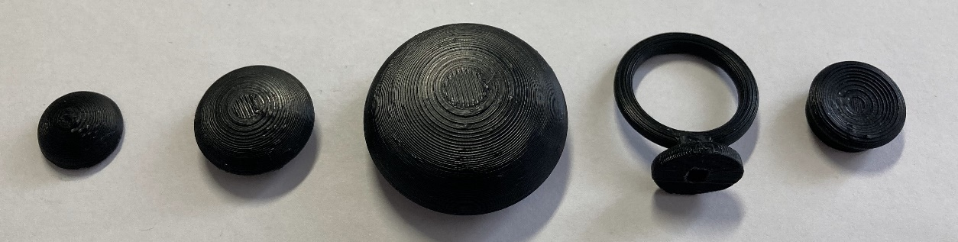

### Usage

1. Plug a USB-C to USB-A cable into the USB-C port on the joystick as shown above.
2. Plug the USB-A end of the cable into the host device (such as the Xbox Adaptive Controller).
3. Wait for joystick to initialize, approximately 15 seconds.
4. Ensure the arrow on the joystick is pointing in the “up” direction, away from the user.
5. Mount the device if needed. Instructions go over three mounting methods:
   1. Table top mounting – non slip pads
   2. Tabletop mounting – hook and loop fasteners
   3. Camera mount with ¼-20 thread
6. Move joystick as you would with a standard controller.

### Cost

$50.87 ($42.87 for components and 3D prints, $8 for shipping)

A more detailed breakdown is available in the bill of materials.

### Build Instructions

The Birch Mini Joystick – U consists of 3D printed parts and electronic components. The Assembly Guide is available at the GitHub repository.

#### Skills Required

* 3D printing
* Soldering
* Microcontroller programming (Arduino)

#### Time Required

3D Printing Time (for all essential components): 3 hours 11 minutes

3D Printing Time (including optional prints, all toppers and mounting): 5 hours 33 minutes

Assembly Time: approximately 1 hour

Software setup time: approximately 15 minutes

#### Tools

* Flush Cutters
* Wire Strippers
* Soldering Iron
* Philips Head Screwdriver
* (Optional for mount adapter) ¼-20 Screw or Hex Bolt, at least ½” long

#### Components

* Mini 2-Axis Analog Thumbstick
* Analog Mini Thumbstick Breakout Board with Included Male Headers
* Universal Proto-Board PCB 4cm x 6 cm
* SeeedStudio XAIO RP2040 with Included Male Headers
* 24 Gauge Wire or Protoboard Jumper Wires
* 8x M2 x 6 mm Self Tapping Screws
* USB-C Cable – 6 ft

#### 3D Printing

* Birch Enclosure Top
* Birch Enclosure Bottom
* Inner Disk
* Overlay

#### Programming

A custom Arduino code (Open_AT_Joystick_Software_Birch.ino) needs to be flashed using Arduino IDE.

### Design

The enclosure was designed using Autodesk Fusion 360.

### Attribution

Designed by Josie Versloot and Tyler Fentie – Makers Making Change